1. 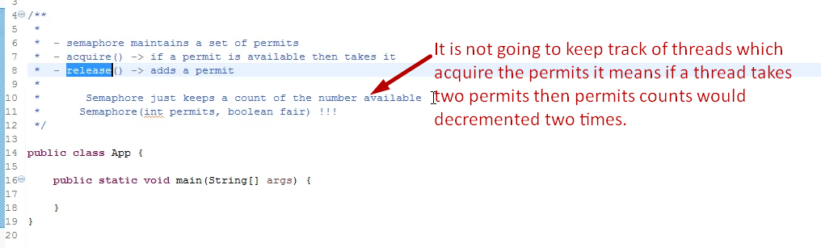
2. 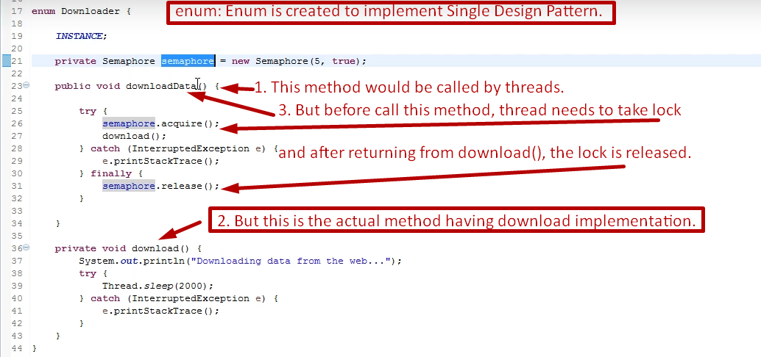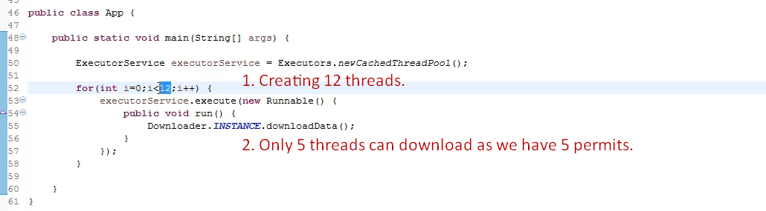
3. **Example**:
   1. **FaceBook**: A lot of download requests for same image come which crash the system.  
      So, restricting only 5 requests can download the same image at a time.